4. Steps for analyzing the data

It is necessary to do correlation analysis after collecting the data for these 6 metrics. The correlation analysis was adopted by the Pearson correlation coefficient and Spearman correlation coefficient.

The Steps of data analysis are as follows:

(1) Determining which two metrics are used for correlation comparative analysis and determining which level of data they are (e.g. package level, class level). Extracting the metric data of specific project from the collected data.

(2) Importing the collected metric data into a MATLAB program in order to calculate their Pearson correlation coefficient and Spearman's rank correlation coefficient. Collecting the correlation coefficient and generating the distribution diagrams of the data.

(3) Comparing the results of the specific metric correlation coefficients of the five projects and conclude the most general conclusion.

5.Results analysis

5.1 Correlation between Metric 1 & 2 and 3.

|  |  |  |
| --- | --- | --- |
| Project | Sets of data (Class level) | *R (Pearson)* of metric 1&3 |
| Total 5 project | 1063 | 0.7476 |
| Apache commons Lang | 89 | -0.0564 |
| Apache commons codec | 52 | 0.8027 |
| Apache commons collections | 264 | 0.4510 |
| Apache commons configuration | 177 | 0.8266 |
| JFreeChart | 481 | 0.7996 |
| Apache commons Lang | 11 sets Package-Level data | 0.3152 |

Table1. *R (Pearson)* between metric 1 & 3

|  |  |  |
| --- | --- | --- |
| Project | Sets of data (Class level) | *R (Pearson)* of metric 2&3 |
| Total 5 project | 899 | 0.7707 |
| Apache commons Lang | 75 | -0.0847 |
| Apache commons codec | 47 | 0.8674 |
| Apache commons collections | 206 | 0.3714 |
| Apache commons configuration | 143 | 0.753 |
| JFreeChart | 428 | 0.7996 |
| Apache commons Lang | 11 sets Package-Level data | 0.8627 |

Table2. *R (Pearson)* between metric 2 & 3

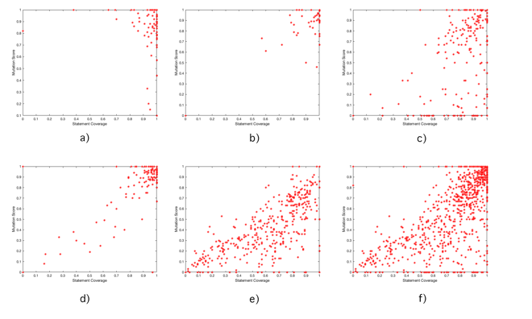

**Figure1** Data distribution diagram of class level between Metric 1 & 3 a) Apache commons Lang b) Apache commons codec c) Apache commons collections d) Apache commons configuration e) JFreeChart f）Total five project class level data

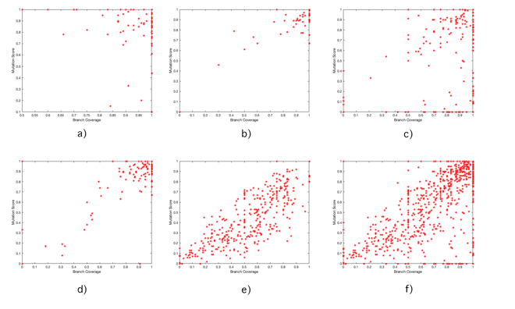

**Figure2** Data distribution diagram of class level between Metric 2 & 3 a) Apache commons Lang b) Apache commons codec c) Apache commons collections d) Apache commons configuration e) JFreeChart f）Total five project class level data

It can be seen from Figure 1 and 2, as well as table 1 and table 2 above that the *R(Pearson)* of the four groups is strong and the direction of the correlation is positive except the ‘Apache Commons Lang’ project. The correlation coefficient of ‘Apache Commons Lang’ project is obviously different from the other four projects.

Hence, we summarized and analyzed the class level data of the five projects and calculated that *R(Pearson)* of metric 1&3 of total 5 projects is 0.7476, and *R(Pearson)* of metric 2&3 of total 5 projects is 0.7707.

As for why the correlation coefficient of the project Apache Commons Lang is very small. We found that the data of the Apache Commons Lang metric 1 and metric 2 is concentrated on more than 90%, as shown in Figure 3. Therefore, the data distribution is too centralized to form a good correlation comparison, and it is easy to cause the deviation of the correlation coefficient on Apache Commons Lang. We specifically list 11 sets of data for the Apache commons Lang package level in Table 1 and Table 2, we can see *R(Pearson)* is strong and positive for metric 1&2 and metric 3. Combining with the similar *R(Pearson)* of the four groups of projects and the universality of the five groups of data, it can be seen considered that the correlation coefficient on the class level of Apache Commons Lang is an abnormal result, which is not universal and can be ignored.

Therefore, we can conclude from the *R(Pearson)* of the five groups of projects that the correlation between metric 1&2 and metric 3 is very strong and positive.

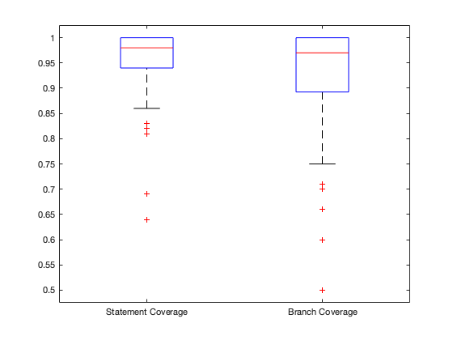

**Figure3** Boxplot of Apache commons Lang class level data of metric 1 and metric 2

5.2 Correlation between Metric 1&2 and Metric4.

The correlation analysis of metric 1&2 and metric 4 was carried out using the Spearman's rank correlation coefficient *rs*.

|  |  |  |
| --- | --- | --- |
| Project | Sets of data (Class level) | *rs* of metric 1&4 |
| Total 5 project | 1663 | -0.3556 |
| Apache commons Lang | 246 | -0.2116 |
| Apache commons codec | 89 | -0.2605 |
| Apache commons collections | 474 | -0.3780 |
| Apache commons configuration | 306 | -0.3694 |
| JFreeChart | 548 | -0.0655 |

Table 3. *rs* between metric 1 and metric 4

|  |  |  |
| --- | --- | --- |
| Project | Sets of data (Class level) | *rs* of metric 2&4 |
| Total 5 project | 1174 | -0.2705 |
| Apache commons Lang | 162 | -0.2985 |
| Apache commons codec | 59 | -0.3509 |
| Apache commons collections | 319 | -0.2614 |
| Apache commons configuration | 197 | -0.3177 |
| JFreeChart | 437 | 0.0958 |

Table 4. *rs* between metric 2 and metric 4

As can be seen from Figure 4 and the Spearman correlation coefficients *rs* of metric 1&4, 2&4 of the five projects in Table 3 and Table 4 above, *rs* of most projects are around -0.3. So we can conclude from these two tables that the correlation between metric 1&2 and 4 is negative and the strength of the association is good but not very strong.

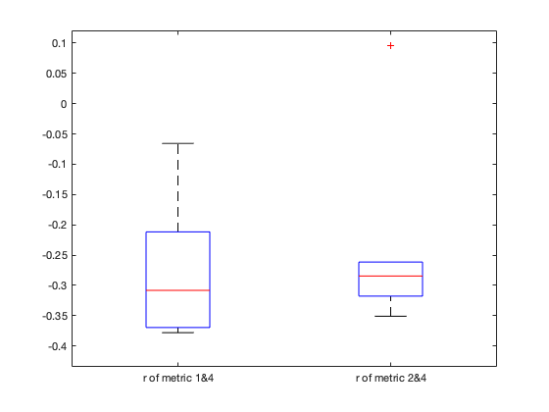

**Figure 4** Boxplot of *rs* of metric1&4 and metric 2&4

5.3 Correlation between Metric 1&2 and Metric 6

|  |  |  |
| --- | --- | --- |
| Project | Sets of data (Class level) | *R (Pearson)*of metric 1&6 |
| Apache commons Lang | 126 | -0.0544 |
| Apache commons codec | 60 | -0.0761 |
| Apache commons collections | 270 | -0.0237 |
| Apache commons configuration | 186 | 0.0404 |
| JFreeChart | 524 | 0.0328 |

Table 5. *R (Pearson)* between metric 1 and metric 6

|  |  |  |
| --- | --- | --- |
| Project | Sets of data (Class level) | *R (Pearson)* of metric 2&6 |
| Apache commons Lang | 108 | 0.0541 |
| Apache commons codec | 47 | -0.0734 |
| Apache commons collections | 206 | -0.0245 |
| Apache commons configuration | 143 | -0.0031 |
| JFreeChart | 428 | 0.0694 |

Table 6. *R (Pearson)* for Metric 2 and Metric 6

The Pearson correlation coefficients *R (Pearson)* for metric 1&2 and metric 6 are shown in Table 5 and Table 6. The absolute *R (Pearson)* of all five projects are less than 0.01. Consequently, we infer that there is almost no correlation between metric 6 and metric 1&2.

5.4 Correlation between Metric 5 and Metric 6

The Pearson correlation coefficient *R (Pearson)* is calculated from the above 14 sets of data, and the value of *R(Pearson)* was 0.2732, so it shows that the positive correlation between metric 5 and metric 6 is medium.

|  |  |  |
| --- | --- | --- |
| Project (Version-Version) | Metric5 BMI | Metric 6 Change proneness |
| Apache commons Lang 3.0-3.6 | 10.833 | 0.00591716 |
| Apache commons Lang 3.6-3.7 | 43.333 | 0.020833333 |
| Apache commons Lang 3.7-3.8 | 33.9683 | 0.017241379 |
| Apache commons codec 1.10-1.11 | 30.5556 | 0.03125 |
| Apache commons codec 1.11-1.12 | 44.4444 | 0.041666667 |
| Apache commons codec 1.9-1.10 | 100 | 0.025641026 |
| Apache commons collections 3.2-4.0 | 40.3175 | 0.00177305 |
| Apache commons collections 4.0-4.1 | 38.611 | 0.005076142 |
| Apache commons collections 4.1-4.3 | 41.6667 | 0.003030303 |
| Apache commons configuration 2.1-2.2 | 66.667 | 0.00990099 |
| Apache commons configuration 2.2-2.3 | 15.7576 | 0.071428571 |
| Apache commons configuration 2.3-2.4 | 3.0303 | 0.005235602 |
| Jfreechart 1.0.18-1.0.19 | 250 | 0.045454545 |
| Jfreechart 0.19-1.5.0 | 66.667 | 0.000770416 |

Table 7. Metric 5 and metric 6 data from different versions of 5 projects

5.5 Conclusions of correlation analysis

According to 5.1, it shows that the correlation between metric 1&2 and metric 3 is positive and very strong. We can conclude that suites with higher statement or branch coverage can show high mutation score. This conclusion is consistent with the rationale that test suites with higher coverage can show better test suite effectiveness.

According to 5.2, it shows that the correlation between metric 1&2 and 4 is negative and the strength of the association is good but not very strong. We can conclude that classes with higher Cyclomatic Complexity show lower statement/branch coverage. This conclusion is consistent with the rationale that classes with higher complexity are less likely to have high coverage test suites.

According to 5.3, it describes that the Pearson correlation coefficients for metric 1&2 and metric 6 were very small, even not greater than 0.1 in absolute value. Therefore, we consider that metric 1&2 and metric 6 are almost uncorrelated. We think that there is no correlation between statement/branch coverage and change proneness.

According to 5.4, it shows that the Pearson correlation coefficients of the metric 5 and metric 6 were positively correlated and moderately strong. We conclude that on the project-level, project with higher Backlog Management Index might show higher change proneness.